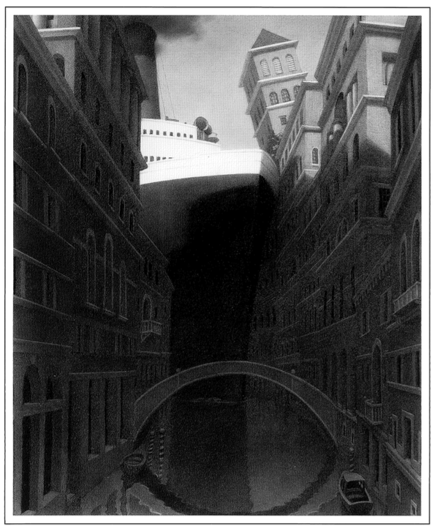1] (Remember, 150 words minimum.)

2] If you were the superintendent for the Washoe County School

District, what would you try to do to make going to school, and

education in general, better?

3] Write about whatever you want.